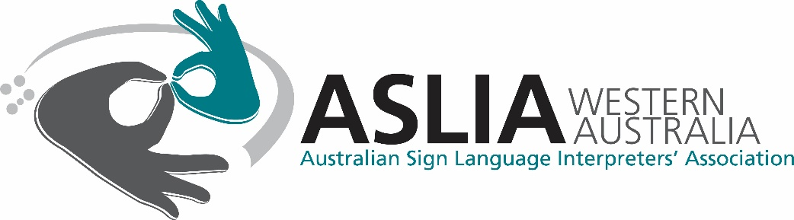

Funding Application
In making an application to ASLIA (WA) for financial assistance to attend events, it should be understood that the successful applicant will, within 6 months of their return, either give a presentation or workshop to share the knowledge and skills they have gained. This will ensure ASLIA (WA) members will benefit by being informed of national and international interpreting developments. ASLIA (WA) will assist the applicant in the organisation of the presentation.
Applications must be submitted with a cover letter providing a written explanation (about 250 words) explaining why you think you should receive this funding, and how you and ASLIA (WA) will benefit.
Personal Details of Applicant
Name
Address
Phone
Email
Member type
Number of years of membership
NAATI Credential level
Year attained
Current employment status
Employers

Details of the Event you wish to attend
Title of event
Institution/organisation offering the event
Contact information
Dates
Location

Expenses
Travel
Meals
Accommodation
Registration
Other
Total
Funds requested from ASLIA (WA)

Have you applied for or received funding from any alternate sources for this event? Yes/No
If yes, please provide details:
_________________________________________________________________________________________________________________________________________________________________________________

Have you received funding from ASLIA (WA) in the past? Yes/No
If yes, please provide details:
_________________________________________________________________________________________________________________________________________________________________________________

Agreement
- I certify that the information provided in this application is accurate to the best of my knowledge.
- I agree to represent ASLIA (WA) in a professional manner and to maintain the ethical standards set down in the Constitution.
- I agree to abide by the conditions set down in this application.

Signature: __________________________
Date: ______________________________

Please Note:
Applications should be received eight weeks prior to the event. This allows the committee to give due consideration to all applications and allow the applicant time to complete their registration, bookings and travel arrangements.

ASLIA (WA) has limited funds and cannot guarantee requests for funds will be forthcoming. To this end, upon consideration of each application, a decision will be made either granting:
- partial allocation of funds,
- full allocation of funds, or
- unable to fund.
You will be notified of the decision within six weeks of ASLIA (WA) receiving the application.

